**IX505001 – Introduction to System Analysis**

**Assessment 2 – OO Modelling Assignment**

|  |  |  |  |  |  |  |  |
| --- | --- | --- | --- | --- | --- | --- | --- |
| Study block | Study Block 5 (March 2019) | | | | | | |
| Date issued | 27/11/2019 | | | | | | |
| Due date | 15/12/2019 | Time | | 17.00 | | | |
| Delivery: | Submit to Moodle before deadline | | | | | | |
| Weighting | 30% | | | | | | |
| Marks out of | 75 | | | | | | |
| Instructions | Complete this cover sheet and attach to you your assignment.   * This assignment must be your own work. * Collusion, copying or plagiarism may result in disciplinary action. * We advise that you keep a copy of this assignment. * Refer to following website for reference related resources:   http://www.cite.auckland.ac.nz/index.php?p=quickcite | | | | | | |
| Student Name |  | | | | | | |
| Student ID No |  | | Cohort number | | | |  |
| Lecturer | Farhad Mehdipour | | Class time | | | | Tue and Thu 13.00 – 16.30 |
| Student declaration: | I confirm that:  This is an original assessment and is entirely my own work.  Where ideas, tables, diagrams etc. of other writers have been used, I have acknowledged the source in every case.  This assignment has not been, nor will be, submitted as assessed work for any other academic course. | | | | | | |
| Signature of student: |  | | | | Date | 15-12-2019 | |

**IX 505001 – Introduction to System Analysis**

**Assessment 2 – OO modelling**

Student Name: Vimitaben Mukeshchandra Vaidya

Student ID: 1000063758

## Abstract

Mr. Care dentist online system is designed to assist daily clinic operation. This system decreases the workload of staff, by decrease complexity of work. All task such as appointment, inventory management and treatment management are done digitally. Patient can add their personal information and manage their appointment by using this system via website or mobile. They can also change their appointment according to schedule. Moreover, patient can check dentist availability for their booking treatment and confirm appointment. Admin staff manage all operation such as update inventory pricing and information and estimated cost of treatment, doctor schedule. The system is also allowing patient to check previous medical history and payment details.

## Requirements Definition

* 1. **Functional Requirements:**
* Patient Management:
  + Insert, update and delete their personal information such as, name, address, contact number, date of birth, family GP, previous dentist, medical history and insurance details.
  + Patients can select generic type of treatment according to their required time.
  + After each appointment, patients can view a report of their treatment details as well as invoice/receipt.
  + Patients can able to view, update and manage their information in system.
* Book appointment
  + Patient can able to book new appointment or update it if patient is register.
  + Patient can able to check the availability of doctor which are shown for appointment.
  + Appointment scheduling will be automatically updated to match notifications to Dentist timetable and activate recalls to patients daily.
  + The system can able to match dentist availability to match appointment on their schedules.
  + The system can confirm appointment, once a slot and treatment are matched with the patients.
* Treatment management
  + The system can able to store patients’ treatments details.
  + The system will able to match treatment type and duration, estimated cost and any pre-treatment care required for patients
* Staff Management (Dentist/Administrative staff)
  + The system can able to store the status of invoice whether it is paid or due
  + Dentist can able to add or edit treatment types.
  + Dentist can able to record their availability on a schedular that will feed the schedule onto Mr. Care to match appointments and schedules.
  + Administrative Staff can able to manage treatment schedule, doctor schedule as well as recalls on a regular basis.
  + Staff/dentist can able to generate weekly schedule at any time.
  + Admin staff should be able to update inventory pricing, information and schedule of dentist on ad hoc request.
  + Each dentist should be able to view and have full access of their own schedule
  1. **Non-Functional Requirements:**
* Performance
  + Response Time: the new software that will provide quick and easy to use for user/ patients.
* Availability
* The system/portal should be available at all time.
* Security
  + Modification: Any update (include insert, delete, alter) in database shall be synchronized and done by administration staff only.
* The system should be able to run on both website and mobile platform.

## User Stories

|  |
| --- |
| **Steering Committee** |
| As a Steeringcommittee,  I need a new software.  So that, I can make it system online and flexible registration process to old/new patients. |
| **New patients** |
| As a new patient  I need to complete online patient information.  So that, I can store my personal information in patient database. |
| **Register patient** |
| As a register patient,  I need to be register in Mr. Care system.  So that, I can make new appointment or change appointment. |
| As a register patient,  I need to be register in Mr. Care system.  So that, I can able to check availability of doctor for appointment. |
| As a register patient,  I need to go through with check list on online/app.  So that, I can solve query on the type of required treatment. |
| As a register patient,  I need to go through with check list on online/app.  So that, I can solve query on recommended time for appointment. |
| As a register patient,  I needed required time for the appointment.  So that, I can select generic type of treatment. |
| As a register patient,  I need to check after each appointment.  So that, I can view report of my treatment details. |
| As a register patient,  I need to check after each appointment.  So that, I can view my Invoice/receipt of treatment. |
| As a register patient,  I need access of portal anytime.  So that, I can manage my information. |
| **Mr. Care Dentist System** |
| As a system,  I need to set reminder on bills.  So that, I can send automatic email/SMS to the patients. |
| **Dentist** |
| As a dentist,  I need to use Mr. Care system.  So that, I can able to manage treatment types available for patients. |
| As a dentist  I need to record my availability on schedular.  So that, Mr. Care can match the appointments and schedules. |
| **Administrative staff** |
| As a administrative staff,  I need a access of Mr. Care system  So that, I can able to manage treatment schedule. |
| As a administrative staff,  I need a access of Mr. Care system  So that, I can able to manage doctor schedule. |
| As a administrative staff,  I need a access of Mr. Care system  So that, I can able to recall on regular basis. |
| As a admin staff,  I need to access Mr. Care system,  So that, I can able to update inventory pricing. |
| As a admin staff,  I need to access Mr. Care system,  So that, I can able to update information and dentist schedules on ad hoc request. |

## Use Case Model

Use case diagram is a methodology used to describe the functionality of system and decide the system stockholders. Each use case focuses on describing how to achieve a task. Here, there are total main four users, patient which is generalize as a register patient and un-register patient. Register patient can do all operation which are for patient can do. Admin staff and doctor is inherited from system. Include and extend define the whether the task is depending or independently perform or not. Extend is arrived when a guard condition is happening with task.

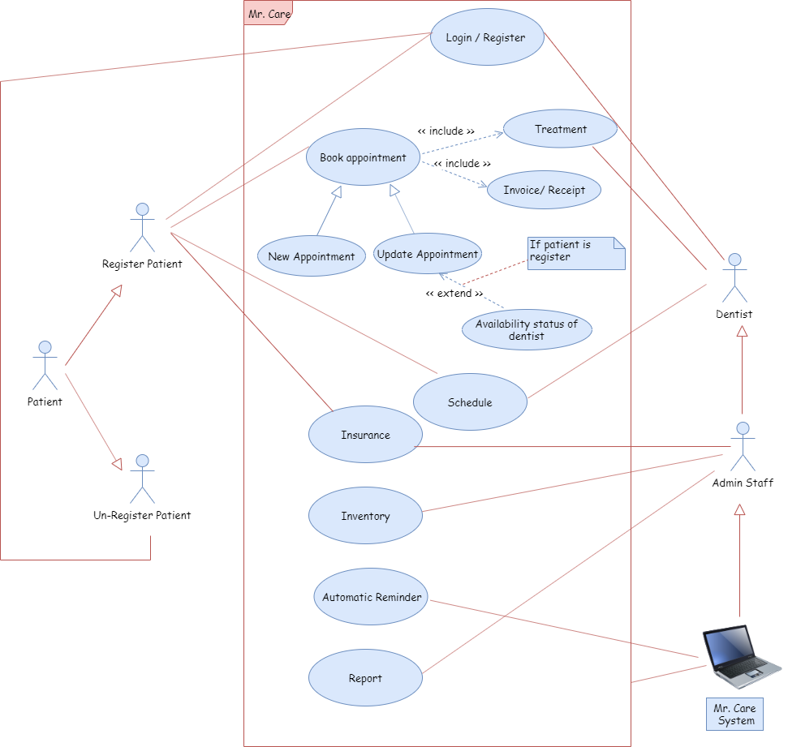

## Class Diagram

Class is a static structure diagram, which is made up of a set of classes with different attributes and methods. It also defines the relationship between classes. Class diagram is helpful for developer as well as for business analysts to model system from a business perspective. Class diagram also include aggregation, composition and cardinality and generalization.

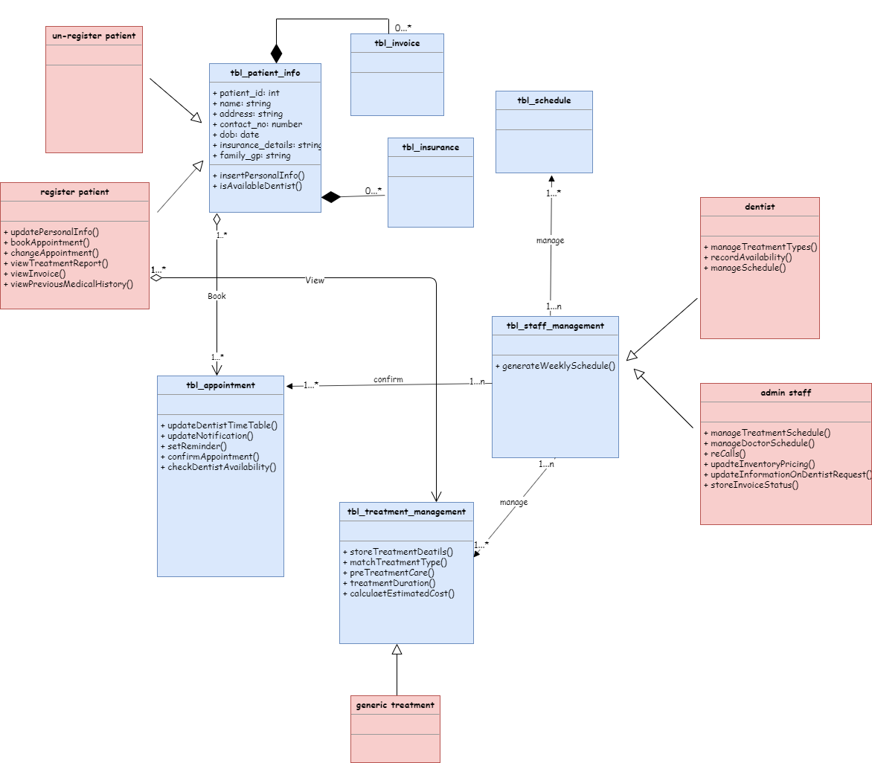

## Activity Diagram

Activity diagram define the process of each operation of the system. The following activity diagram are categorized in three different process done by patient, doctor and admin staff. Each activity diagram decides the task done by actor.

## **Activity Diagram for Patient**

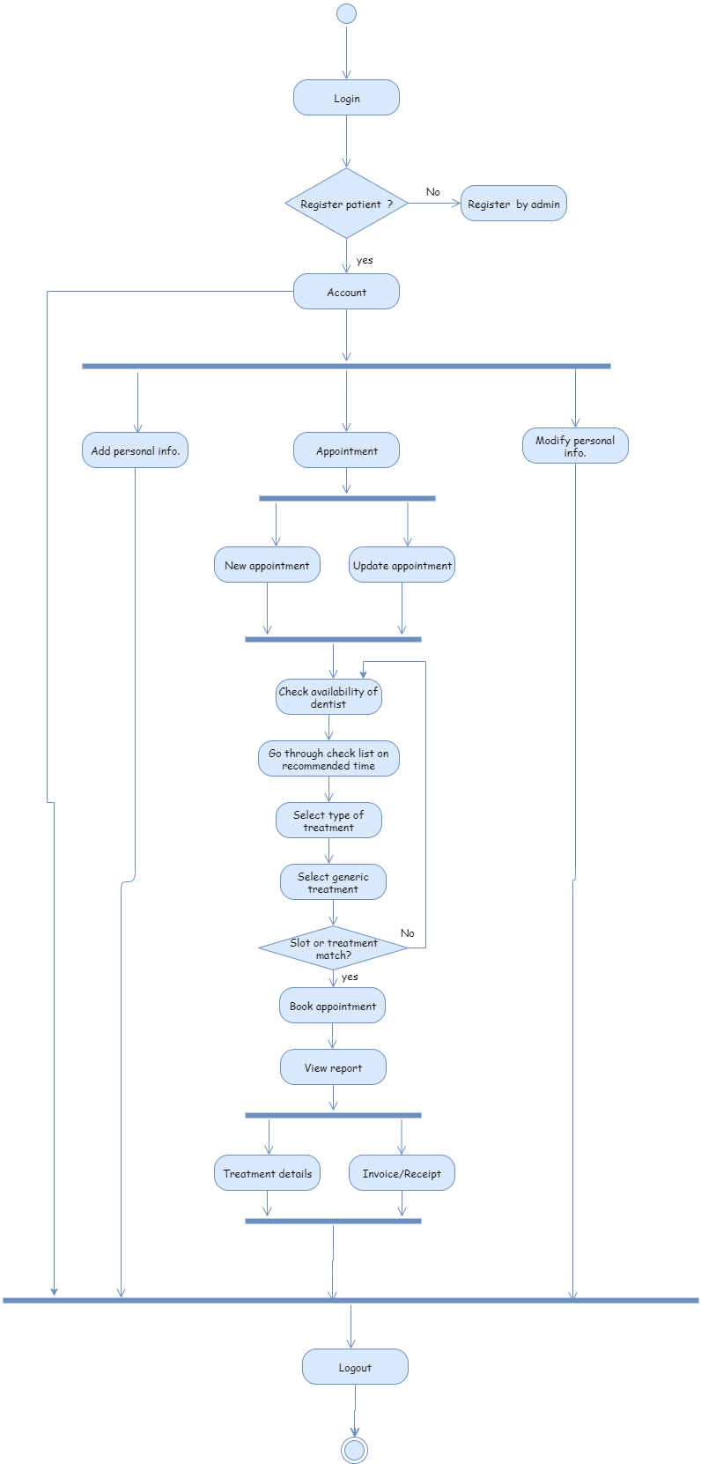

## **Activity Diagram for Dentist**

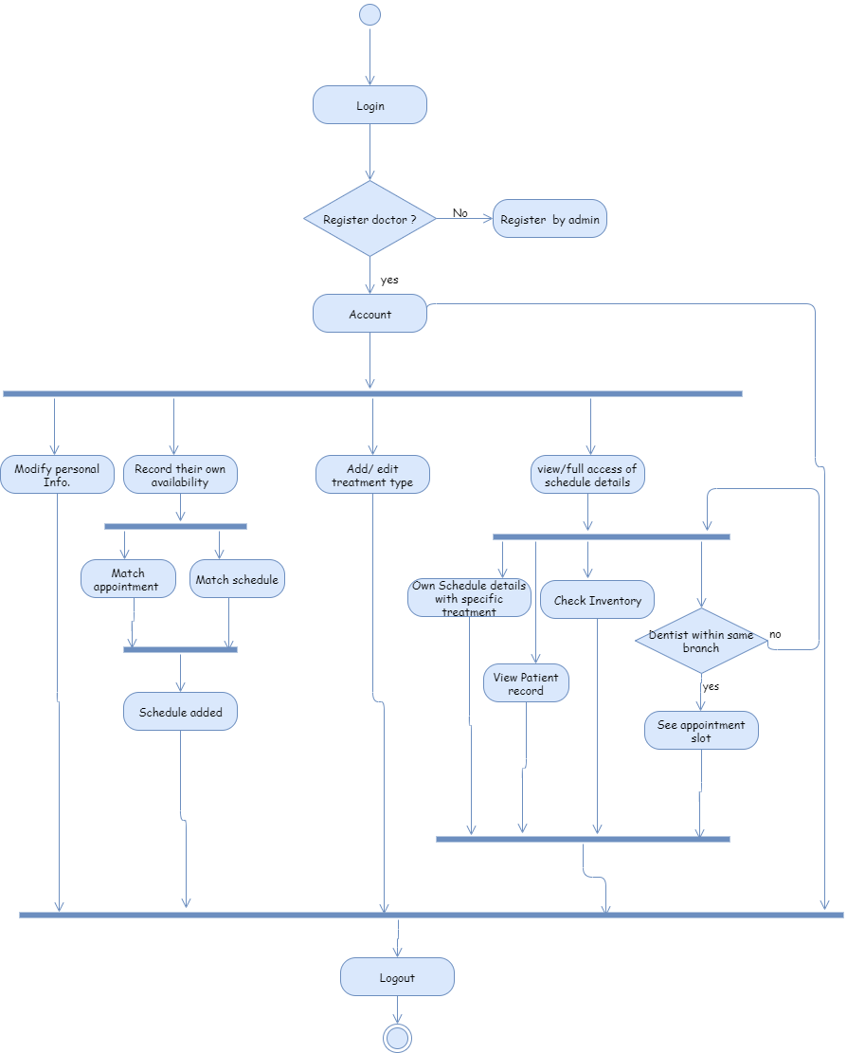

## **Activity Diagram for Admin**

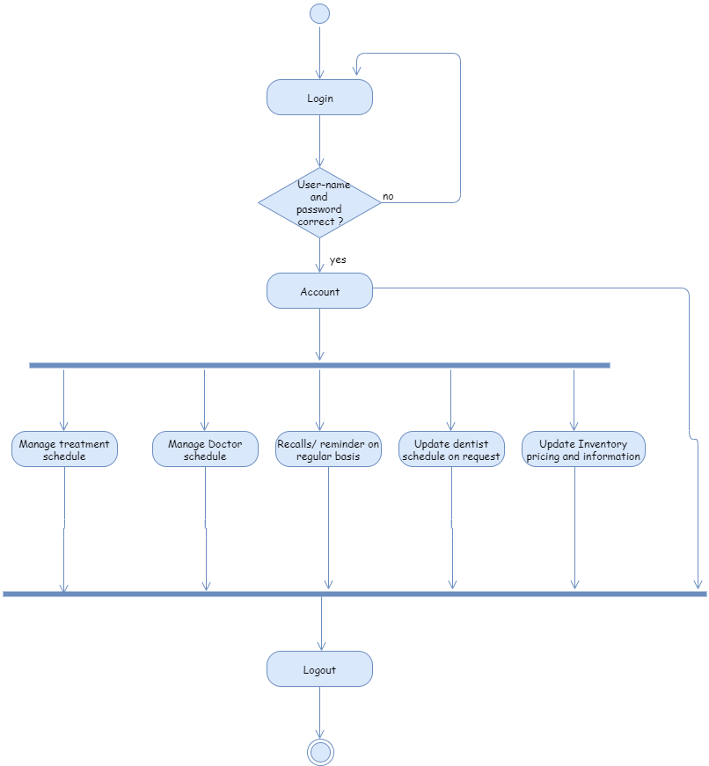

## Evidence of Professional Practice

This assignment is about the task which has to be done by developer before building software. As in software development life cycle is key things when we are going to build a new system. Here, I was analysed an online dental clinic software Mr. Care requirement and design the UML (Unified Modeling language) diagram, which define the system stake holders, how system will work and process of the system.

After received requirements, my task was to separate the functional and non- functional requirements, make a user story which define the actor of system and their work. Then after I need to draw and design class diagram, use case diagram and activity diagram and at the end write an evidence of my practice in professional language.

I did reverse engineering to manage my assignment task. For each point from given requirements I decide the what are the functional and non-functional requirements, decide the actor and made user story. Moreover, for the same point I made a roughly decision of diagrams and find is there any condition or not. These all task I did in Microsoft word file by highlighting each task using different colour. After completion of this, I made a roughly diagram on paper which are converted in proper structure at the end by using software tool draw.io. While drawing a diagram I faced some difficulties to decide the relationship, also in the software tool I haven’t find all shapes of diagram easily. After doing this all task I merged my work into single word file and organized in a given templet by adding extra explanation of each diagram.

As a result, this object-oriented modelling assignment improve my software skill, and business analyst skill. It gives me a brief knowledge of how to analyse a system requirements and design a UML (unified modelling language) diagram.